About the planets

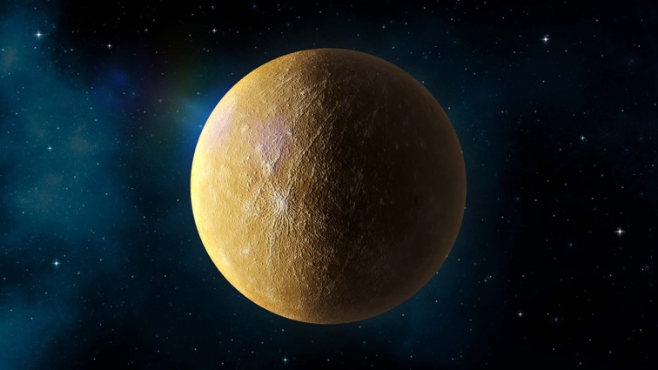
MERCURY

About Mercury

Mercury is the smallest planet in our solar system and the one closest to the Sun. Because it is so close, Mercury experiences extreme temperatures, becoming very hot during the day and extremely cold at night.

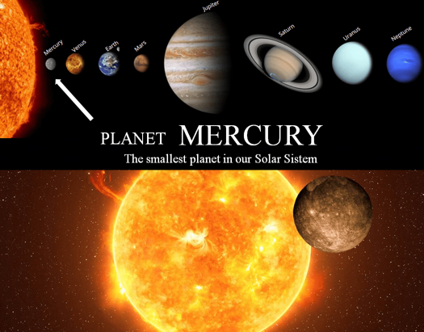
Key Facts
- Closest planet to the Sun
- No atmosphere to trap heat
- One year on Mercury is very short

Fun Facts
- A day on Mercury is longer than its year
- Temperatures can change dramatically
- Mercury has many craters, similar to the Moon

Planet Connection
Mercury is closest to the Sun, while Neptune is the farthest. This is why Mercury is very hot during the day, and Neptune is extremely cold.

Did You Know?
Mercury has no air to breathe, which means sound cannot travel there.

Quick Quiz
Question: Is Mercury hotter during the day or at night?
Answer: During the day
- Which planet is closer to the Sun: Mercury or Earth?
- Does Mercury have an atmosphere like Earth?

VENUS

About Venus
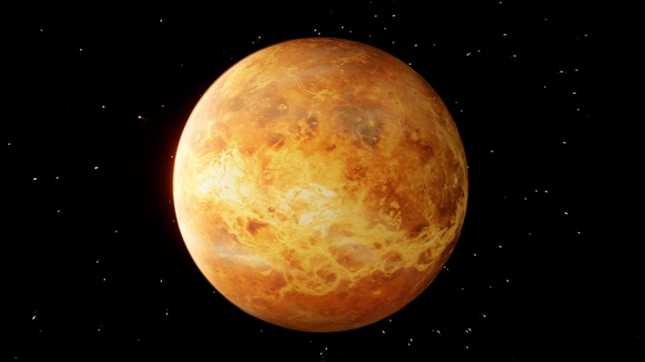
Venus is often called Earth’s twin because it is similar in size, but its environment is very different. Thick clouds trap heat, making Venus the hottest planet in the solar system.

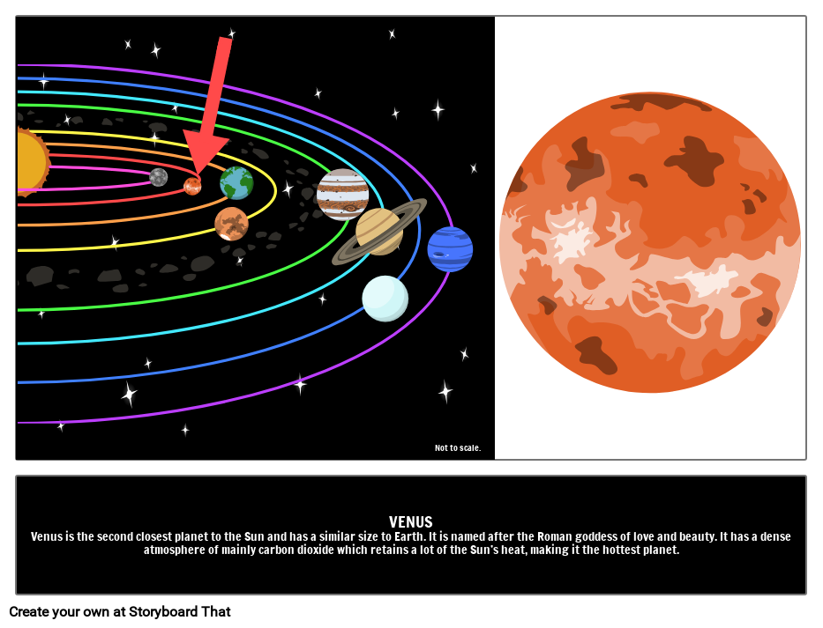
Key Facts
- Second planet from the Sun
- Covered in thick clouds
- Very hot surface temperature

Fun Facts
- Venus spins in the opposite direction to most planets
- A day on Venus is longer than a year
- It shines brightly in the night sky

Did You Know?
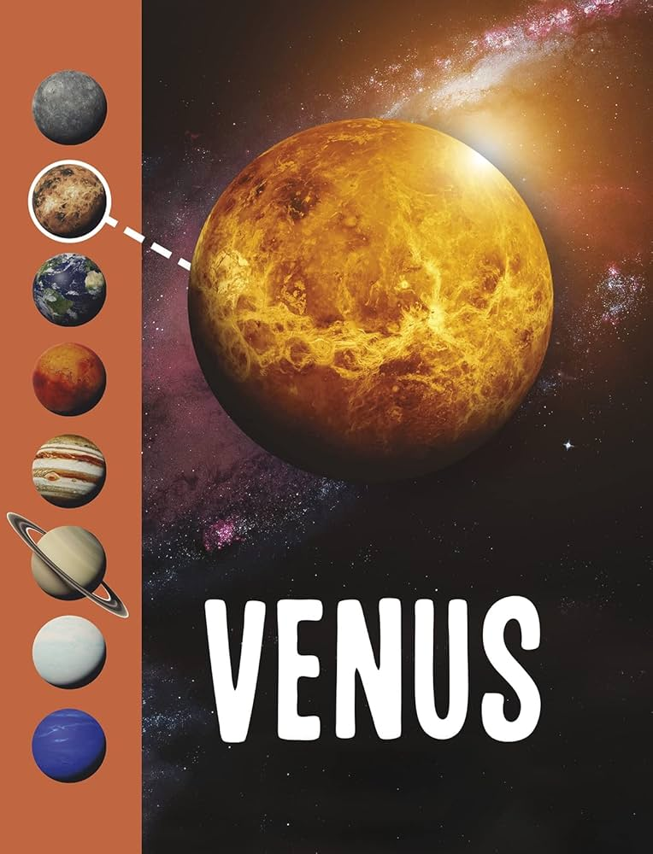
Venus is sometimes called the Morning Star or Evening Star.

Planet Connection
Even though Venus is not the closest planet to the Sun, it is hotter than Mercury because its thick clouds trap heat.

Quick Quiz
Question: Is Venus hotter than Mercury?
Answer: Yes
• Which planet is hotter: Venus or Mercury?
• Why does Venus stay hot even at night?

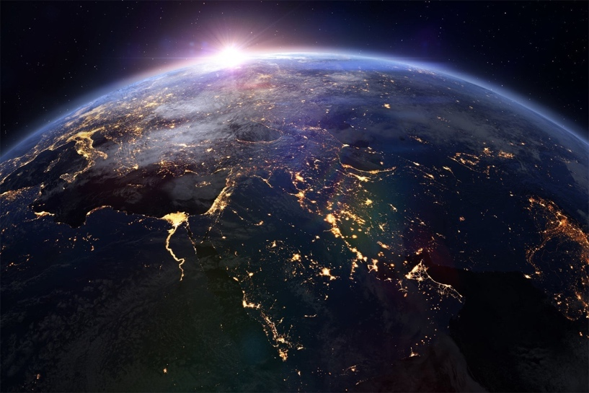
EARTH

About Earth

Earth is the only planet known to support life. It has air to breathe, water to drink, and the perfect distance from the Sun to keep temperatures comfortable.

Key Facts
- Third planet from the Sun
- Has liquid water
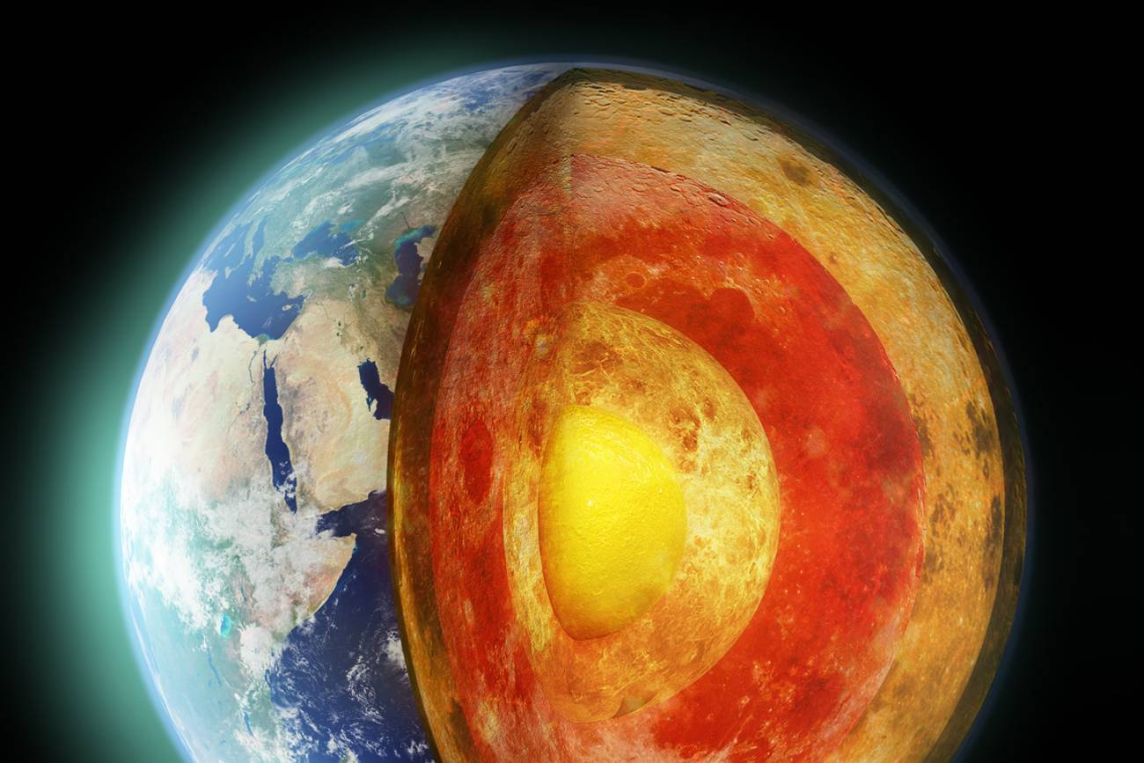
- Supports life
Fun Facts
- Earth is always moving but we don’t feel it
- Over 70% of Earth is covered by water
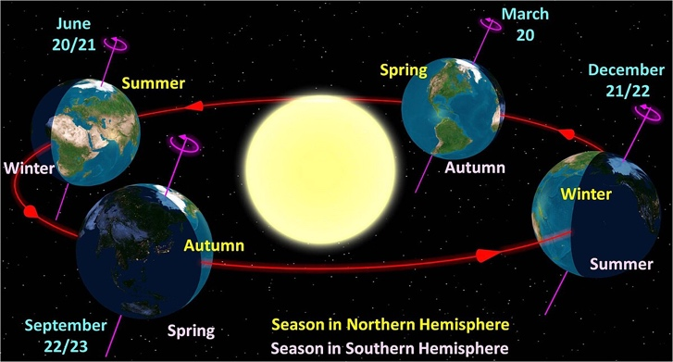
- Earth has one Moon

Planet Connection
- Earth is very different from Venus and Mars because it has liquid water and breathable air, which allows life to exist.

Did You Know?
Earth’s atmosphere protects us from harmful rays from the Sun.

Quick Quiz
Question: What makes Earth special?
Answer: It supports life
• Which planet supports life: Earth or Mars?
• What does Earth have that Mercury does not?

MARS

About Mars

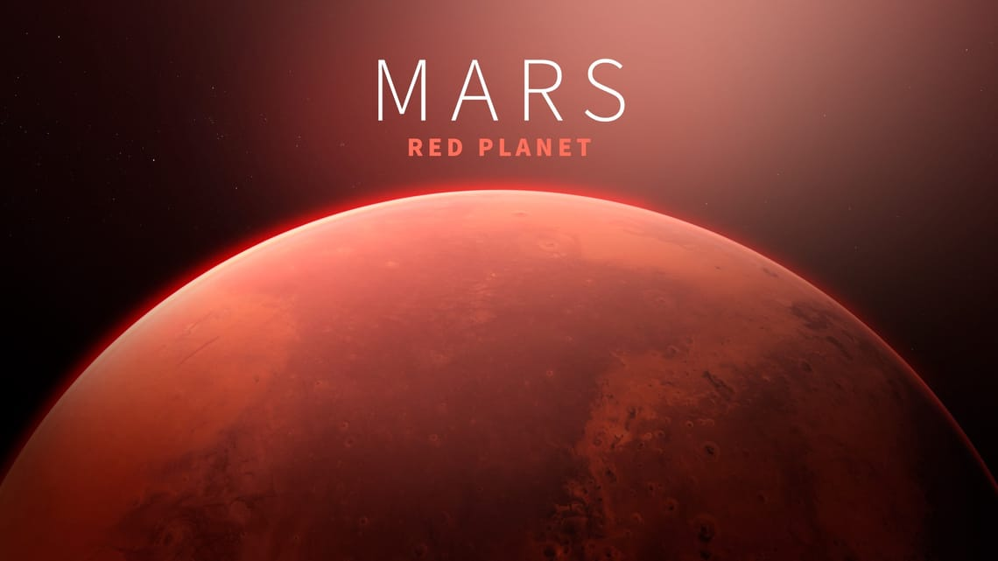
Mars is known as the Red Planet because of its rusty colour. Scientists believe Mars once had water, which makes it interesting for future exploration.

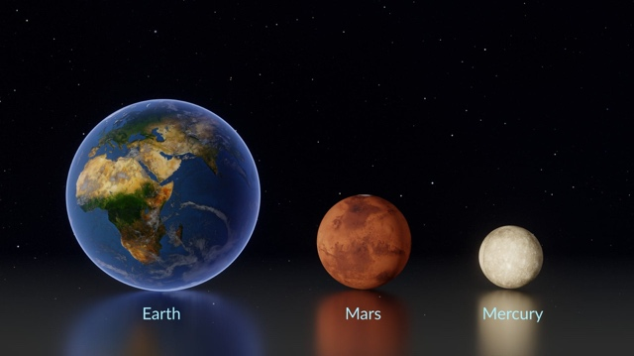
Planet Connection
Mars and Earth both have seasons, but Mars is colder because it is farther from the Sun and has a thinner atmosphere.

Key Facts
- Fourth planet from the Sun
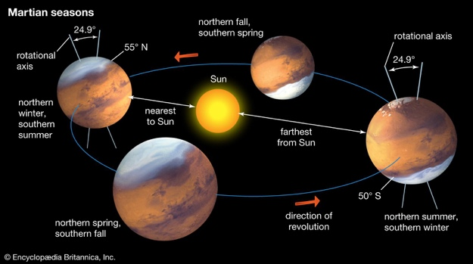
- Cold and dusty
- Has the tallest volcano in the solar system
Fun Facts
- Mars has two small moons
- Strong dust storms can cover the planet
- Robots explore Mars for signs of life

Did You Know?
Mars has seasons similar to Earth.

Quick Quiz
Question: Why is Mars red?
Answer: Because of iron dust
• Which planet is colder: Earth or Mars?
• Why do scientists study Mars so closely?

JUPITER

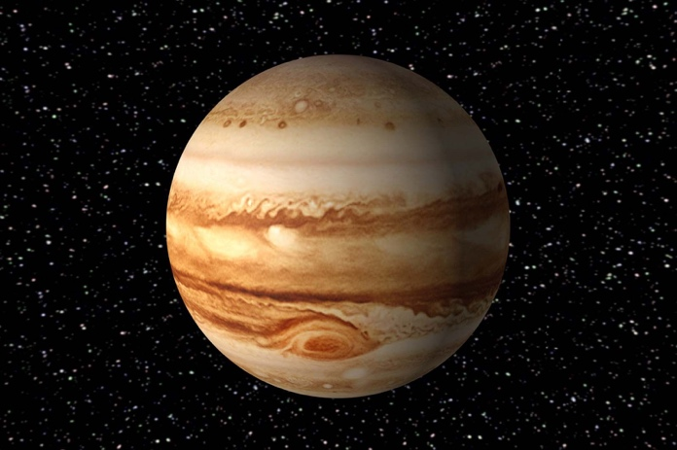
About Jupiter

Jupiter is the largest planet in the solar system. It is a gas giant made mostly of gases and has a famous storm called the Great Red Spot.

Key Facts
- Largest planet
- Made mostly of gas
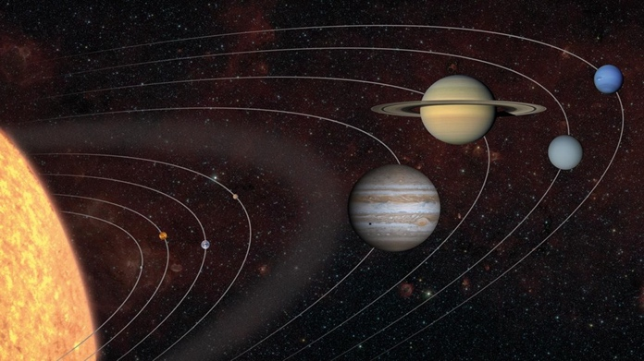
- Has many moons

Fun Facts
- Jupiter’s storm is bigger than Earth
- It has over 70 moons
- Strong gravity

Planet Connection
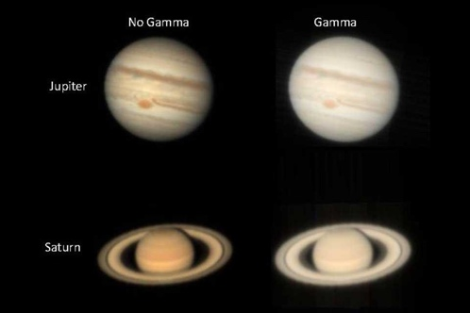
- Jupiter is much bigger than Earth and is made of gas, while Earth is solid. Its strong gravity helps protect smaller planets.

Did You Know?
Jupiter helps protect other planets by pulling in asteroids.

Quick Quiz
Question: Is Jupiter solid?
Answer: No
• Is Jupiter bigger or smaller than Earth?
• Is Jupiter a solid planet?

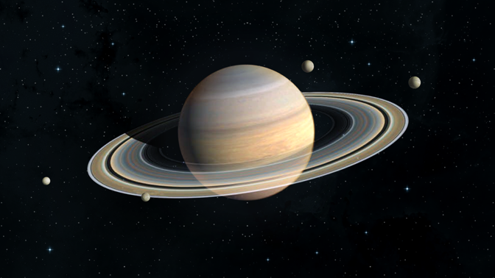
SATURN

About Saturn
Saturn is famous for its beautiful rings, made of ice and rock. It is another gas giant and has many moons.

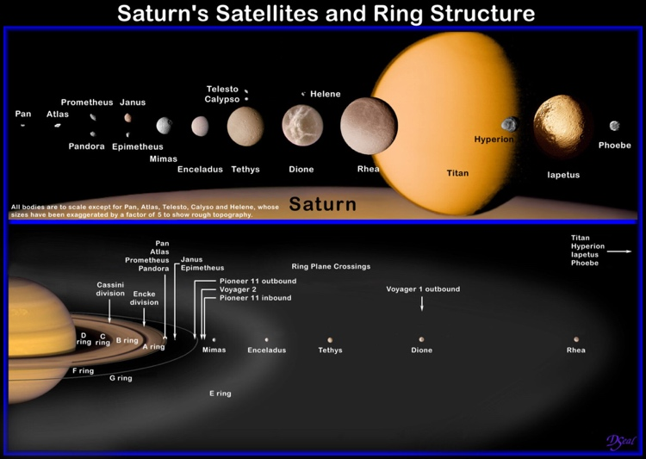
Key Facts
- Known for its rings
- Gas giant
- Very light for its size

Planet Connection
- Saturn and Jupiter are both gas giants, but Saturn is famous for its rings, which are made of ice and rock.
- Saturn and Jupiter are both gas giants, but Saturn is famous for its rings, which are made of ice and rock.

Fun Facts
- Saturn could float in water (theoretically!)
- Rings are made of ice and dust
- Has dozens of moons

Did You Know?
Saturn’s rings are very wide but very thin.
- Which planet has rings: Saturn or Earth?
- Are Saturn’s rings solid or made of pieces?

Quick Quiz
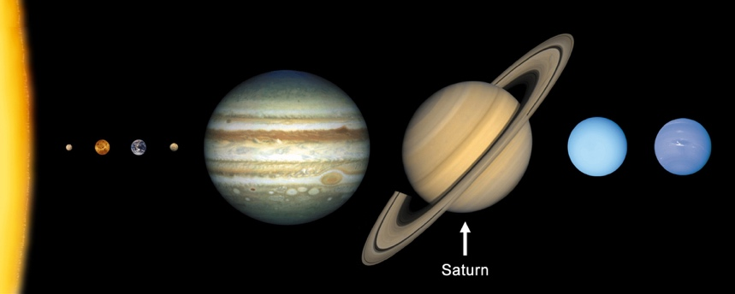
Question: What are Saturn’s rings made of?
Answer: Ice and rock
• Which planet has rings: Saturn or Earth?
• Are Saturn’s rings solid or made of pieces?

URANUS

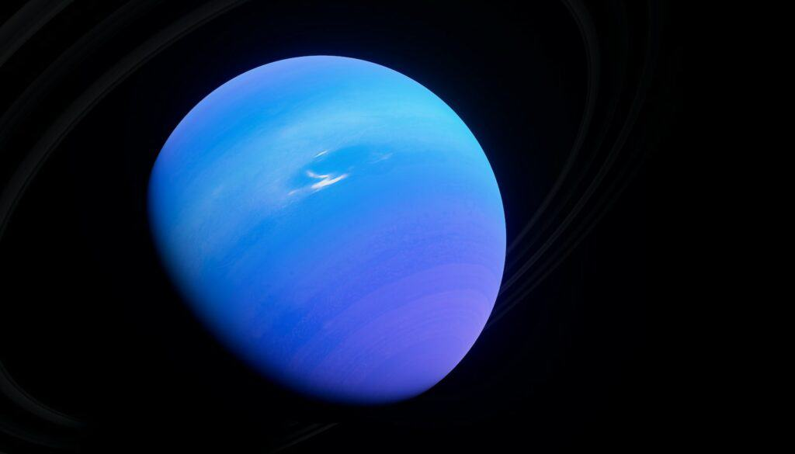

About Uranus
Uranus is unique because it tilts on its side, making its seasons extreme. It appears blue due to gases in its atmosphere.
Uranus is different from all other planets because it spins on its side, while Earth and most planets spin upright.

Key Facts
- Spins sideways
- Blue-green colour
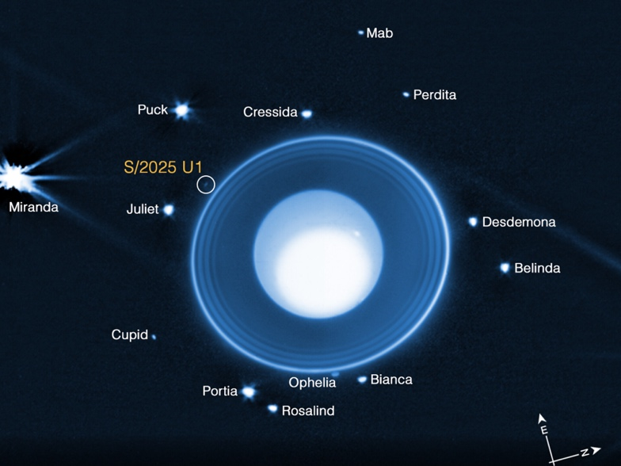
- Very cold

Fun Facts
- Coldest planet
- Long seasons
- Gas giant

Did You Know?
Uranus takes 84 Earth years to orbit the Sun.

Quick Quiz
Question: Why is Uranus special?
Answer: It spins on its side
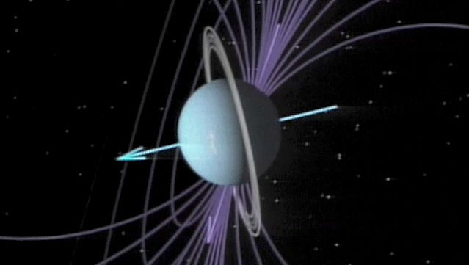
• Which planet spins on its side?
• Does Uranus have short or long seasons?

NEPTUNE

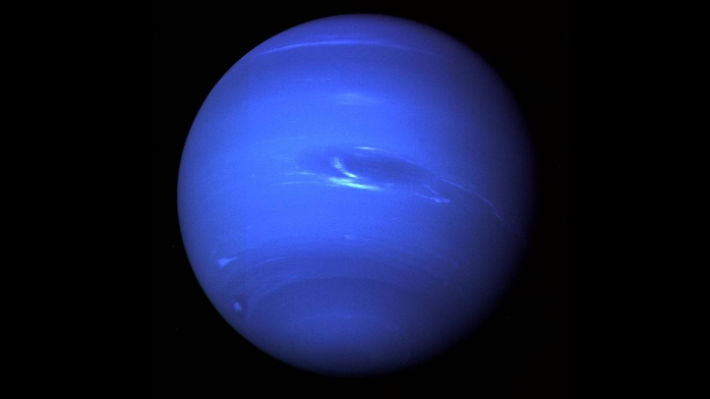

About Neptune
Neptune is the farthest planet from the Sun. It is known for strong winds and a deep blue colour.
Neptune is the farthest planet from the Sun and is much colder and windier than Earth.

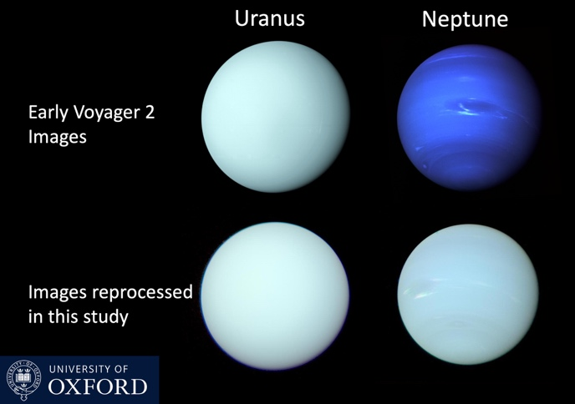
Key Facts
- Farthest planet
- Very windy
- Cold temperatures

Fun Facts
- Fastest winds in the solar system
- Dark storms appear and disappear
- Named after the god of the sea

Did You Know?
Neptune’s winds are faster than a jet plane.

Quick Quiz
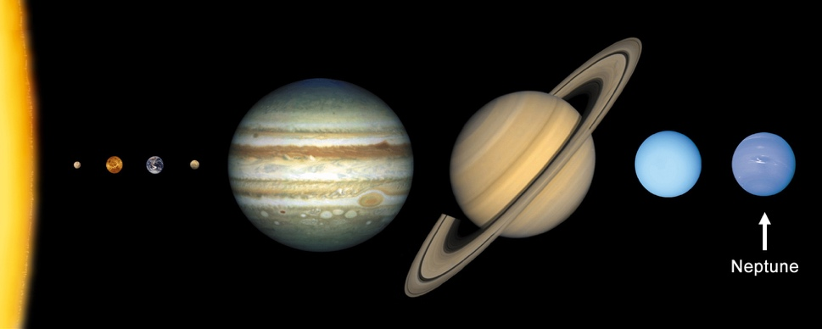
Question: Is Neptune warm or cold?
Answer: Cold
• Which planet is the farthest from the Sun?
• Are Neptune’s winds slow or fast?

